**Practical File**

of

**Fundamentals of C Programming**

**(24CSE0107)**

**Batch-2024**

**Bachelor of Engineering (CSE)**

|  |  |
| --- | --- |
| **Submitted By**  **Student Name: Ishank Dattana**  Roll No. 2410990355  Group No., Sem: 2nd, BE (CSE)  Chitkara University, Punjab, 140401  India | **Submitted To**  **Faculty Name: Dr. Mohammed Shuaib Khan**  Assistant Professor, CSE  Chitkara University, Punjab, 140401  India |

**Department of**

**Computer Science and Engineering,**

**Chitkara University School of Engineering and Technology,**

**Chitkara University, Punjab, India**

**Index**

|  |  |  |
| --- | --- | --- |
| **Sr. No.** | **Experiment** | **Page No.** |
| 1 | Install C compiler (GCC/Code::Blocks), set up IDE, compile and run the first "Hello, World!" program. | 3 |
| 2 | Write a Program to show the use to input (Scanf)/output (Printf) statements and block structure of C-program by highlighting the features of "stdio.h". | 4 |
| 3 | Write a program to add two numbers and display the sum. | 5 |
| 4 | Write a program to calculate the area and the circumference of a circle by using radius as the input provided by the user. | 6 |
| 5 | Write a Program to perform addition, subtraction, division and multiplication of two numbers given as input by the user. | 7 |
| 6 |  |  |
| 7 |  |  |
| 8 |  |  |
| 9 |  |  |
| 10 |  |  |
| 11 |  |  |
| 12 |  |  |
| 13 |  |  |
| 14 |  |  |
| 15 |  |  |
| 16 |  |  |
| 17 |  |  |
| 18 |  |  |
| 19 |  |  |
| 20 |  |  |
| 21 |  |  |
| 22 |  |  |
| 23 |  |  |
| 24 |  |  |
| 25 |  |  |
| 26 |  |  |
| 27 |  |  |
| 28 |  |  |
| 29 |  |  |
| 30 |  |  |
| 31 |  |  |

**Experiment No. 1.**

**Aim:** Install C compiler (GCC/Code::Blocks), set up IDE, compile and run the first "Hello, World!" program.

**Concept Used:** A "Hello, World!" program in C includes the #include <stdio.h> library for input/output, defines a main function as the entry point, uses printf() to display "Hello, World!", and ends with return 0; to signal successful execution. This structure is the basis for more complex C programs.

**Program**:

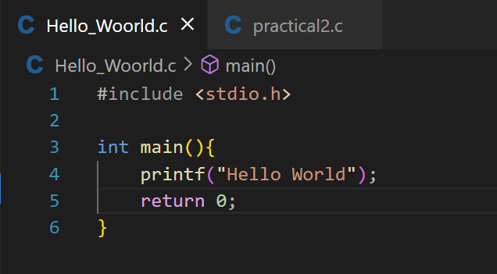

**Output Screenshot:**

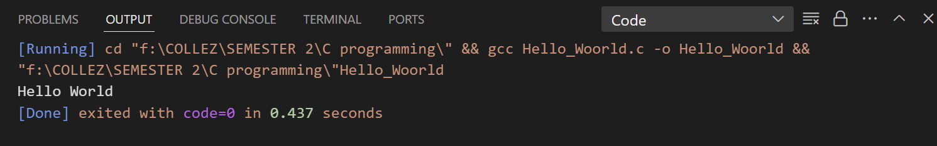

**Experiment No. 2.**

**Aim:** Write a Program to show the use to input (Scanf)/output (Printf) statements and block structure of C-program by highlighting the features of "stdio.h".

**Concept Used:** The program demonstrates the use of input (scanf) and output (printf) functions in C, along with the block structure of the program. By including the stdio.h library, the program gains access to these functions for reading user input and displaying output. The block structure is evident in the organization of the code, where the main() function serves as the entry point and contains the logic for input and output. The scanf() function reads input from the user, while printf() displays the entered value. This program highlights how user interaction is handled in C and the importance of organizing code into blocks to structure the flow of execution.

**Program**:

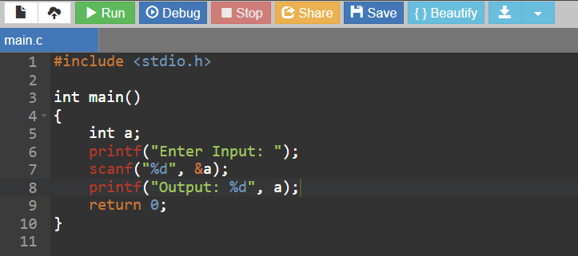

**Output Screenshot:**

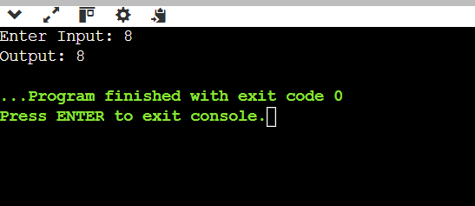

**Experiment No. 3.**

**Aim:** Write a program to add two numbers and display the sum.

**Concept Used:** The concept behind this program is to demonstrate basic input and output operations in C using the scanf and printf functions. The program prompts the user to enter two numbers, reads these inputs using scanf, calculates their sum, and then displays the result using printf. This simple structure shows how to perform arithmetic operations and interact with the user in C while highlighting the use of variables, input/output functions, and basic arithmetic.

**Program**:

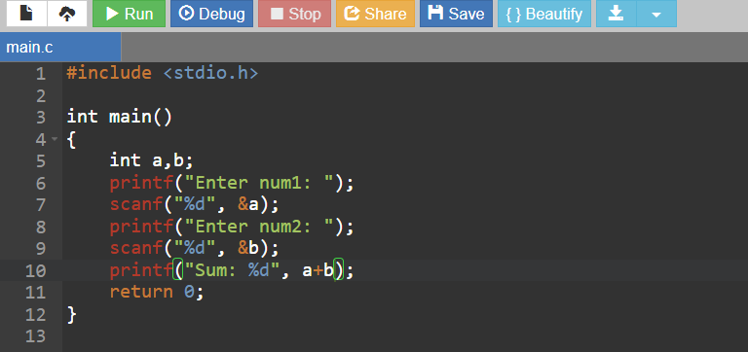

**Output Screenshot:**

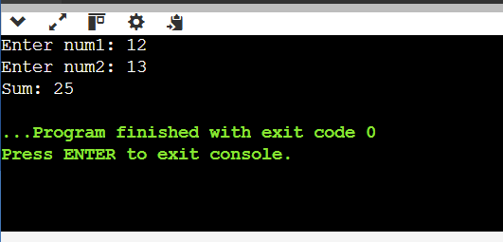

**Experiment No. 4.**

**Aim:** Write a program to calculate the area and the circumference of a circle by using radius as the input provided by the user.

**Concept Used:** This program calculates the area and circumference of a circle based on the user's input for the radius. It uses the formulas Area = π * r² and Circumference = 2 * π * r. The program takes the radius as input, performs the calculations, and displays the results to the user.

**Program**:

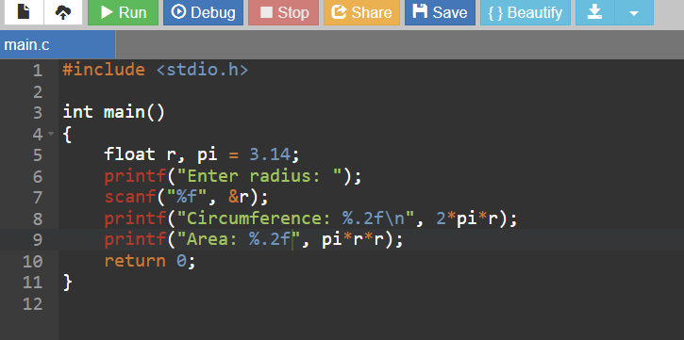

**Output Screenshot:**

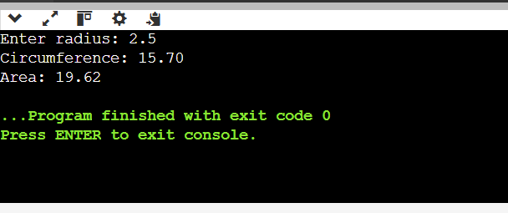

**Experiment No. 5.**

**Aim:** Write a Program to perform addition, subtraction, division and multiplication of two numbers given as input by the user.

**Concept Used:** This program performs addition, subtraction, multiplication, and division on two numbers entered by the user. It uses basic arithmetic operators (+, -, *, /) to calculate the results and displays them using printf. The program demonstrates how to take user input with scanf, store results in variables, and display the output.

**Program**:

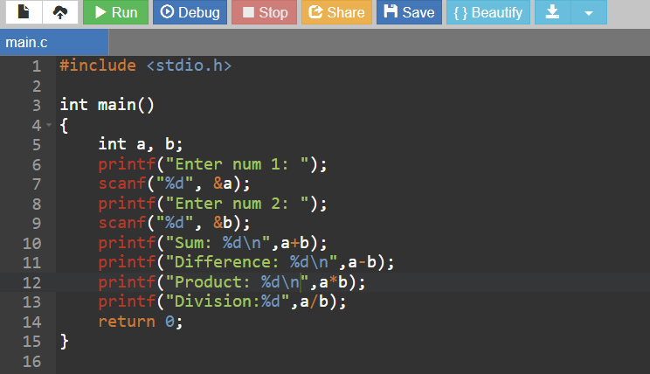

**Output Screenshot:**

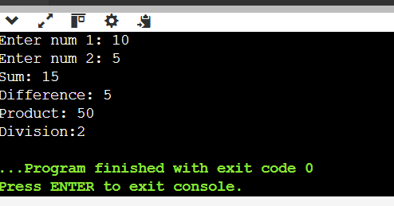

**Experiment No. 4.**

**Aim:**

**Concept Used:**

**Program**:

**Output Screenshot:**

**Experiment No. 4.**

**Aim:**

**Concept Used:**

**Program**:

**Output Screenshot:**

**Experiment No. 4.**

**Aim:**

**Concept Used:**

**Program**:

**Output Screenshot:**

**Experiment No. 4.**

**Aim:**

**Concept Used:**

**Program**:

**Output Screenshot:**

**Experiment No. 4.**

**Aim:**

**Concept Used:**

**Program**:

**Output Screenshot:**